Welcome or welcome back to your dispute resolution studies with Mediation Institute.
This guide offers goal-setting and time-management assistance adapted from best-selling author Laura Vanderkam’s TED Talk, “How to gain control of your free time.”
It is designed help you achieve your goal to become a dispute resolution professional or upskill —without feeling overwhelmed.

Achieving GOALS
- Establish your goal and be clear on what you want and why
- Break them into manageable steps or milestones
- Make a game plan for the next week, every week, using your calendar, our calendar, and the role play scheduler

- Have you ever struggled to make time for everything?
- Have you set goals for yourself but struggled to achieve them?
- Do you feel like your days are full, but the important stuff never gets done?
- Do you wish you could do other things during downtime–for example, spend less time on your phone or watching TV?

These exercises will help you set your priorities and make sure they get done

Activity 1: Review key takeaways from Laura’s talk
In her TED Talk “How to Gain Control of Your Free Time,” Laura Vanderkam explains how to fit in the things that really matter. What are some of your takeaways?
Here are some of ours

Stop saying you do not have time for things
What we say repeatedly become our beliefs and our beliefs define the boundaries of our reality. When we say, “I don’t have time,” it often means, “It’s not a priority.” Laura says she could tell you she does not have time to dust her blinds, but that would not be true: “If you offered to pay me $100,000 to dust my blinds, I would get to it pretty quickly.” So instead of saying you do not have time, be real with yourself. Say, “I don’t do my studies because it’s not a priority.”

The key to time management is to treat your priorities as though they are urgent
If an emergency crops up, you will drop everything to make time for it. For example, when a woman’s water heater broke, she found seven hours in her busy week to deal with the disaster. We need to treat our goals like emergencies—as though they are a water heater flooding our homes––instead of thinking we’re too busy to work on them.

Know that you can do amazing things in small time windows
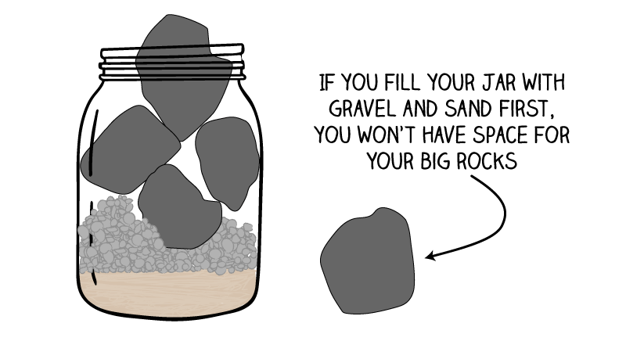
Small moments of time can have great power. You can use your free moments for joy, such as choosing to listen to something wonderful on the drive to work or while going for a walk or planning in advance to go for a ten-minute walk with the kids when you get home.

Activity 2: Define your goals for achieving your qualification in 2021

STEP 1: WRITE YOUR PERFORMANCE REVIEW FOR THIS YEAR
- A great way to achieve success is to visualize it. We often look back on our performance but rarely take the time to look ahead to realizing our goals. One way to do that is by writing your own performance review for 2021— now!
- Pretend it is the end of 2021 and you are giving yourself a performance review for what you have achieved in relation to your studies and career goals.
- Of course, it has been an absolutely amazing year for you professionally. What three to five things did you do that made it so amazing?
For example:
“I established a regular study schedule and really applied myself to my course.”
“I practiced my questioning skills with everyone I met till it became so easy to ask great questions that I even impress myself sometimes!”

STEP 2: WRITE OUT YOUR GOALS
- Use your vision for your performance review to identify one or two learning / career goals you can set for this year.
- Make them SMARTIE Goals. Specific | Measurable | Achievable | Realistic | Timed (put in a target date) | Inspirational (Does looking at the goal inspire you?) | Emotional (What emotions do you feel when considering your goal?)

Goal One:
Goals Two:

STEP 3: GET SOME ACCOUNTABILITY SUPPORT
- Read your goal out loud to yourself, with positive emotion! It is not woo woo.
You program your brain by setting intentions and you tell it that it is important with emotions.
- Share it with your family
- Share it with your teacher
- Share it at tutorials

Activity 3: Break your goals into doable steps

STEP 1: BRAINSTORM MILESTONES TOWARDS YOUR GOAL
- Choose the first goal you identified in Activity 2.
- If your goal achievement date is more than a month away set some monthly milestones.
- Working back from the achievement date or forward from now work out the big steps needed to be achieved and establish those milestones (smaller goals) that will mean inevitably you achieve your goal if you do them or if you miss achieving one you can get back on track quicker.
- Add additional rows and put in each month needed to achieve your goal and the milestone for that month.
For instance, if your goal one is to complete the Grad. Dip. FDR by October and goal two is to start establishing your professional practice in January 2022 you will need to establish a milestone for each month of 2021.
If your goal is to become NMAS Accredited by April 2021 you will only need milestones up to April. Although if your second goal is to be working as a mediator by the end of the year you will want to extend out as well.

Make sense? Just right click in the table and add as many rows as you need and change the start month if you are doing this later.
Month | Milestone Goal

Jan 2021

Feb 2021

Step two: Work out your weekly action steps
- Work out which one or two small steps you want to do next and write them down.
- These will be things that you need to do this month to achieve this month’s milestone.
- Some might relate to new ongoing habits you are going to establish such as attending a role play to observe, participate as a role player, or participate as a mediator every week.
- Some might relate to specific assignments, activities and so on.
Step 1
Step 2

Step 3: Setup Reminders
If you were having trouble with your time management, make sure you have got something to advance your progress in your course and career goal every week!
To make sure your priorities make it into your schedule, it is helpful to calendar them in advance every week.
- You can do this on Friday afternoon, like Laura, or some time each weekend.
- Choose the same time every week so it becomes a habit.
- You may even want to schedule your time for scheduling so that it actually happens.

Using the Learning Management System Calendar
- Go to your course and click the calendar icon on the main menu to open the calendar. You can also open the calendar from the dashboard or from any course you are enrolled in on the lower right of the screen.
- Click on the + and add action step tasks to your calendar as reminders. You have your own private calendar only you can see.

Activity 4: Time Audit (optional)
If you really do not think you have the time to progress towards your learning and career goals do a Time Audit.
A key step toward spending your time on achieving your goals is to learn how you are really spending it already. The exercise below is a time audit that shows you exactly how you use your time. You can do it over the next week or two.
- If you are old school, you can do this manually on a piece of paper you draw up into various categories
- You can use software such as Clockify which is a free and very helpful tool. https://clockify.me/
- Laura Vanderkam has various resources on her website. https://lauravanderkam.com

Step 1: Track your time
- Over the next week, throughout the day make brief notes on how you have spent your time. You do not have to stop to do this every 5 minute although if you are using Clockify you should update it every time you change your activity. You can log later if you are offline. If you do these time-use logs three to four times a day, that should be often enough.
- Keep going for a week or two to get a detailed picture of how you spend your time. If you are on holidays you may have to wait till you are back to work to get the full picture.
- After you have done that for the time you decided add up the hours devoted to major categories—work, sleep, family time, housework, TV, exercise, volunteering, commuting, social media, internet use, shopping.
- We are not just talking about work time and you may want to break “work” into subcategories to learn more about your workday: “meetings,” “email,” “completing projects,” and so on.

Step 2: Schedule in the important things
- Once you have the data you can then find out where you are not using your time as effectively as you could and schedule in some more of the important stuff.
- Ask yourself:
  - What am I happy about in my schedule?
  - What would I like to spend more or less time on?
- Then make changes. Schedule the things that matter most to you. If you want more time with your kids, schedule it in. If you need time to complete your action steps towards achieving your goal, schedule that in as well.

One Action
If this is all a bit overwhelming or you are coming up with excuses for why this might work for some people but not for you, why not break it down a bit?
What is “One Action”—one concrete thing you are going to do before next week to take a step closer to your learning or career goal?

